Rent Account Standing Order Mandate

1. Your bank details

Full name

Address
Your bank’s name |  |  |  |  |  |  |  |  |  |  |  |  |  | Branch

Your bank’s address
Your bank account number |  |  |  |  |  |  |  |  |  |  |  |  | Sort code number

2. Standing order details

Recipients Name

London Borough of Ealing
Recipient’s Bank |  |  |  |  |  |  |  |  |  |  |  | Branch
Lloyds Bank PLC |  |  |  |  |  |  |  |  |  |  |  | HEAD OFFICE COLLECTION ACCOUNT
Recipient’s account number |  |  |  |  |  |  |  |  |  |  |  |  | Recipient’s sort code number
0 | 2 | 3 | 9 | 0 | 1 | 6 |  | 7 |  |  |  |  | 3 |  | 0 | 0 |  | 0 | 0 | 0

Rent account number: TencyRef

(Please quote this account number with ALL payments made)

Monthly payment due
1 Instalment of £00.00 due on XX/XX/XX |  |  |  |  |  | & |  |  | Thereafter 11 instalments of £00.00 due on the 15th of each Month until further notice
Your signature: |  |  |  |  |  |  |  |  |  |  |  |  |  |  |  |  | Date:

Please sign and return this form to your bank or building society
*This order cancels all previous orders in respect of the below mentioned account details

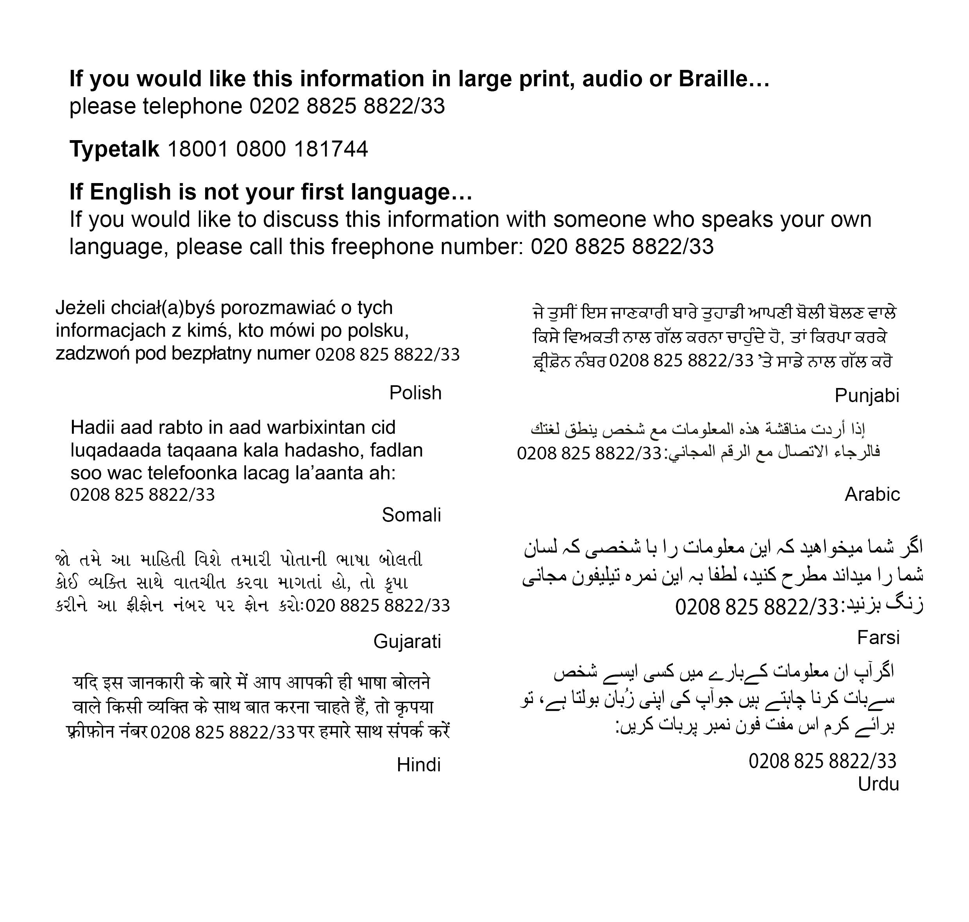

How to pay your rent

Post Office: By swipe card

At the Bank: By cheque
At Perceval House: Self service payment facility
By Standing Order: From your bank account. Contact your Housing Officer for a form and/or further details
By Direct Debit: Contact your Housing Officer for a form and/or further details
From your salary: If you are employed by London Borough of Ealing
Telephone payments: 020 8825 9534 (9am–5pm)

